|  |  |  |
| --- | --- | --- |
| **Design plan: Store Desktop Application** | **Document Name: Document Design** | **SWD/Form No.6** |
| **Effective Date: 3/22/2017** | **Version: 1** | **Page No.1/2** |

|  |  |  |  |  |  |
| --- | --- | --- | --- | --- | --- |
| **Name of the Table** | **Table Description** | **Number of Fields** | **Primary Key** | **Related Tables** | **Foreign Key** |
| Supplier | Suppliers’ information | 5 | SupplierID | 1. Supplying |  |
| Supplying | Supplying times | 4 | SupplyingID | 1. Supplier  2. SuppliedProduct | Supplier (SupplierID) |
| SuppliedProduct | Supplying’ Products as Product for sell | 8 | SuppliedProductID | 1. Supplying  2. Product  3. Selling  4. Order | Supplying (SupplyingID), Product (ProductID) |
| Category | Category | 2 | CategoryID | 1. Product |  |
| Producer | Producers’ information | 5 | ProducerID | 1. Product |  |
| Product | Product’ information | 6 | ProductID | 1. Category  2. Producer  3. SuppliedProduct | Category (CategoryID), Producer (ProducerID) |
| Customer | Customer’ information | 5 | CustomerID | 1. Selling  2. Order |  |
| Selling | Selling (Retail) | 6 | SellingID | 1. Customer  2. SuppliedProduct | Customer (CustomerID), SuppliedProduct (SuppliedProductID) |
| Order | Order (Wholesale) | 7 | OrderID | 1. Customer  2. OrderDetail | Customer (CustomerID) |
| OrderDetail | Order Detail | 4 | OrderID, SuppliedProductID | 1. OrderDetail  2. SuppliedProduct |  |
| User | User’ information | 5 | UserID |  |  |

|  |  |  |
| --- | --- | --- |
|  | **Prepared By (Student)** | **Approved By (Teacher)** |
| **Date: 3/22/2017** | **Nguyen Phuoc Nguyen** | **Luong The Anh** |
| **Design plan: Store Desktop Application** | **Document Name: Document Design** | **SWD/Form No.6** |
| **Effective Date: 3/22/2017** | **Version: 1** | **Page No.2/2** |

ER

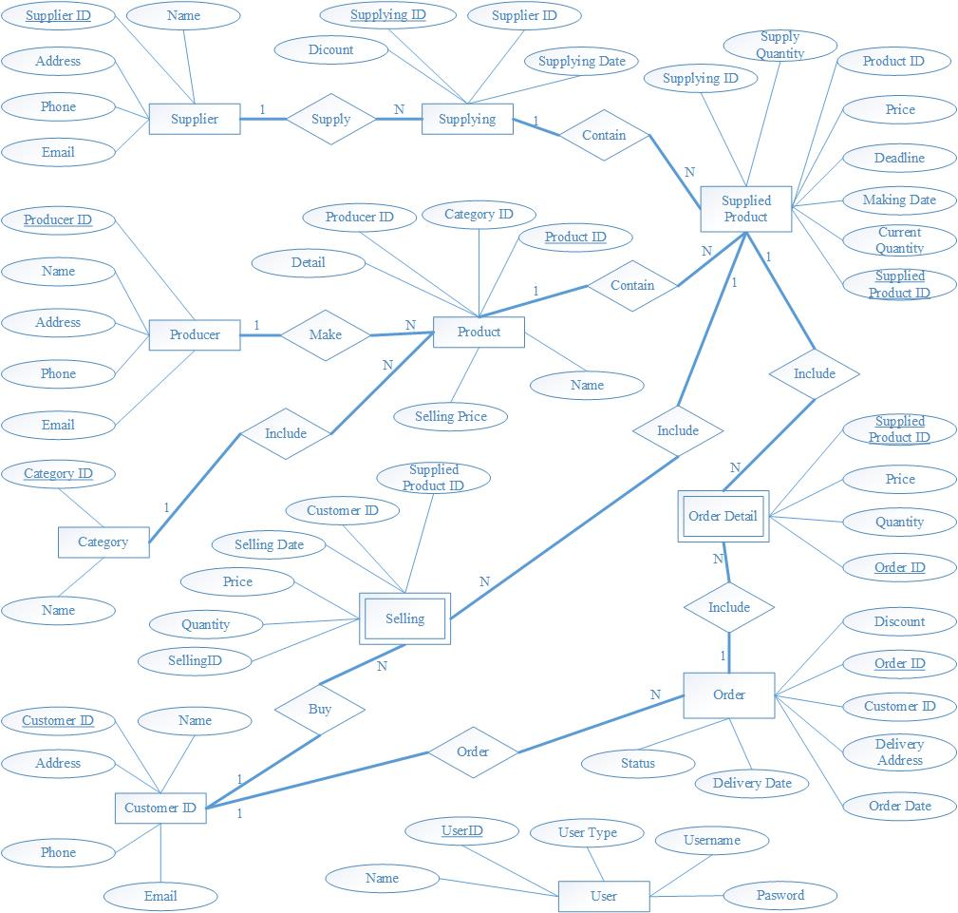

|  |  |  |
| --- | --- | --- |
|  | **Prepared By (Student)** | **Approved By (Teacher)** |
| **Date: 3/22/2017** | **Nguyen Phuoc Nguyen** | **Luong The Anh** |